ASSEMBLY

Assembly of metal components with additional proprietary parts, is a core competency of Hydram. Tasks include fitting component parts including fastenings, castors, hinges, inserts and other modules, such as electrical fit-out. Finishing touches such as silk screen printing and product brand labelling are undertaken. Hydram is also certified to DIN6701 for the use of adhesive bonding in the manufacture of rail vehicles and parts of rail vehicles.

**PAINTING**

Hydram have 3 paint lines – a manual spray conveyor, an offline facility and an automatic line. The auto line uses the latest Gema automated spraying equipment to provide maximum consistency and allows up to 90% powder recycling and quick colour changes. The plant offers a five-and-a-half stage pre-treatment system which can achieve up to 1,000 hours salt spray resistance.

THE FULL RANGE OF SUBCONTRACT

SERVICES

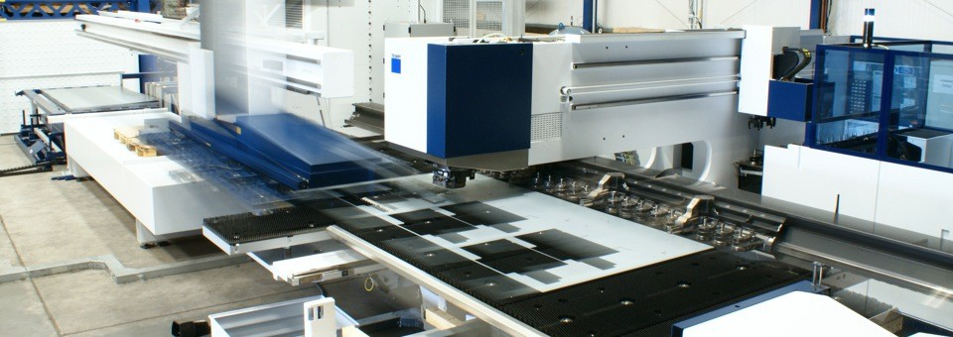

DYNAMIC USA

Dynamic is a privately-owned business with its main headquarters in Michigan, USA specialising in supplying precision metal components for the aerospace, defence, automotive and rail sectors.

• Roll Forming

• Ring Rolling

• Cold/Hot Sizing

• Hand and CNC Spinning

• Hydroforming

• 5-Axis Machining

• 6-Axis Laser Cutting

• Thermal Technologies

• Window Systems

**FORMING**

**Sheet metal bending**

12 pressbrakes with the latest bending technologies to ensure optimum set up times and ease of programming.

**Salvagnini panel bending**

Automated bending of mild steel to 2.5mm and aluminium to 3mm. Zero set up time and fast production.

**Tube Bending**

Hydram manufacture over 350 different handpoles for

buses and trains with variable radii and axis along the length of the tube.

Hydram also offer press shop facilities, CNC machining and CNC rolling.

**WELDING**

**Robotic welding**

Ensuring consistency and economy on longer production runs the maximum component size for Hydram’s 3 Panasonic cells is 150kg and 2200mm long.

**MIG/TIG**

Hydram’s welders are coded to ISO3834-2 and to various industry specific standards including BS EN 15085 Class 1 for the rail sector.

**Metal Dressing**

General preparation and grinding of welds to re-applying grain on stainless fabrications. Supplemented by automated tube and plate deburring machines.

**PROFILING**

**Flatbed laser cutting**

Two fibre and one CO2 laser with automated material handling for sheets up to 3 x1.5m.

**CNC Punching**

Suited to simpler profiles and larger volumes Hydram's two Trumpf T5000 machines generate simple formed features such as dimples, louvres, logo indentations and knock-outs with efficiency and cost effectiveness.

**Tube Laser**

Two BLM machines are designed to cut both hole profiles and end profiles (mitres or cod mouths) on round, square, oval, triangular and other special section tubes.

